Michaëlle Jean Public School
180 Williamson Drive East
Ajax, ON L1Z 0G7
T - 905-686-4440 F – 905-686-4441
www.ddsb.ca/school/michaellejeanps
Twitter : @michaellejeanps

Principal: C. Douglas Vice Principal: L. Lewis
christina.douglas@ddsb.ca lanya.lewis@ddsb.ca
905-239-6753

Superintendent: M. Hamid mohamed.hamid@ddsb.ca 905-666-5500
Trustee: P. Barnes patrice.barnes@ddsb.ca 905-666-5500
School Secretarial Staff: R. Henderson, K. Fontaine
December 2019
A Message from the Principal….
Hello MJPS families!

It has been a wonderful first few months of the school year at Michaëlle Jean PS. Our students from JK to Grade 8 have been working hard, learning a lot and having fun. Above all else, our number one priority will always be our student's safety. Please see below​ ​a few updates and reminders on how we can work together to keep every child safe:

Morning drop-offs: please only drop your child off at the designated spot on each side of the school (where the curb is indented). Allowing your child to get out on the street, in the outside lane of the Kiss N Ride or anywhere else is not safe with the high volume of cars moving around our school. Additionally, please remember that when leaving the school parking lot on the east side, only a right hand turn is permitted.

Our soccer field has recently been given some TLC by the facilities department from the school board. They spent a day removing rocks and then laid several inches of mulch. Now that our students have compacted it down, it provides a much softer cushion when playing soccer.

Our students will be outside every day for a minimum of 40 minutes unless it is raining or the temperature is below -15 degrees. Please ensure your child is dressed appropriately. Ideally, 2 pairs of mittens/gloves should be sent so that when one pair is wet after the first recess, a dry pair is available for the second recess.

Thank you for your ongoing support and partnership. Together we can make our school a great place to learn and grow.
C. Douglas
Principal

School Community Council
Everyone is welcome to attend the SCC meeting which will be held on Thursday, December 5, 2019, at 6:30 p.m. in the library. Free childcare is available.

To communicate questions to the SCC, feel free to email the general mailbox at:
scc410@scc.ddsb.ca
Gr. 3 & 4  Stem Night | STEM Night – Gr 3 & 4’s Only  When: December 5th, 2019  TIME: 6 :00-7 :45pm  COST: $20.00 per student  There are only 24 spots available, and your child’s spot must be reserved by registering them on School Cash Online.  Registration can only be done on School Cash Online, and we will not accept walk-in payments in the office.
Big/Little Winter Concert (JK/SK):
When: Thursday, December 12th, 2019
Where: MJPS Gym
Time: 8:30-9:15am
Kindergarten Families are invited.

Evening Holiday Concert (Gr 1,2 & 6-8):
When: Thursday, December 12th, 2019
Where: MJPS Gym
Time: 6:30-7:30pm
November 2019 | The following students received Above & Beyond nominations from their teachers on November 29th:  Anaia K. Yusuf M. Katelyn C. Taylor D. Victoria T.  Immanuel M. Hanna W. Tristan C. Chance K. Saathuran N.  Eldana S. Aurelia S. Ishaan S. Kaviien K. Ashayla N.  Zehra P. Aarhan S. Yousuf W. Vernan S. Mariam B.  Chelsea S. Ashwin S. Abhimanyu S. Zakir A. Zohaib K.  Vehnessa D. Amisha T. Zahara R. Aliya N. Suji E.  Aliyah K. Priscilla S. Sabeela B. Noah H. Sanaai W.  Cailyn A. Thomas G. Kallen M. Samah R. Luka R.  Munashae P. Faith K. Trinity M. Nicole F. Charly H.  Tishaunn S. Marissa B. Colton D. Kaizeen G. Bahar S.  Svaramy S. Ava B. Colin B. Amir S. Chloe E.  Aliza A. Zayn V. Oyinda A. Mehr J. Kayla E.
Check out the amazing grade 7 ecosystem models in the front foyer display case!
All of the grade seven students created a diverse array of ecosystem models for everyone to enjoy. There are many elements of different ecosystems that are included to inform the audience of living and non-living components interacting with each other. Congratulations to everyone on a job well done!
 | 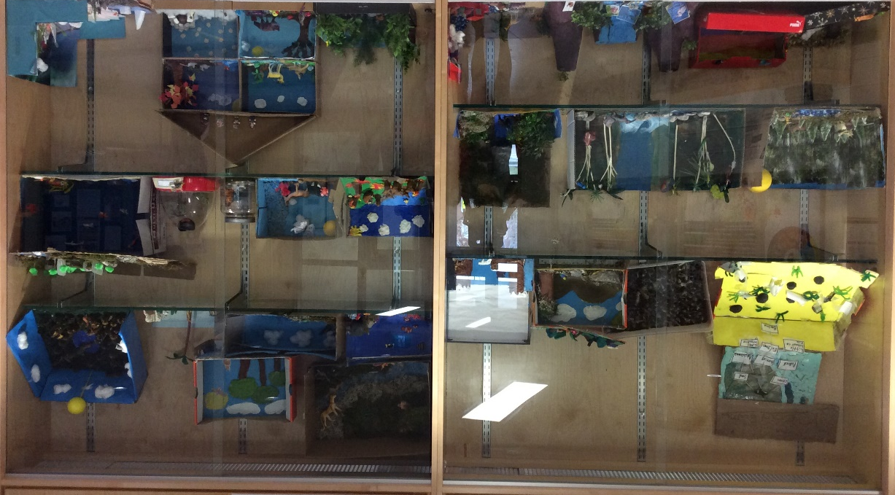
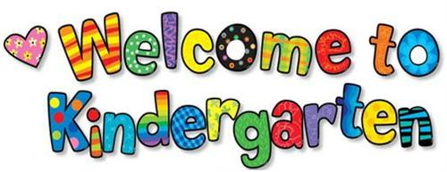 | JK Registration for September 2020  Junior Kindergarten registration for September 2020 will open on January 13th, 2020 at 4:00pm.  Registration is online only, and can be done at: https://www.ddsb.ca/en/our-schools/register-for-school-registering-for-kindergarten.aspx
school cash online
For safety and security reasons the Durham District School Board would like to reduce the amount of cash and cheques coming into the school. Please take a moment to register for School Cash Online, so that you can pay for items at school easily from home. First, go to the School Cash Online home page at https://DDSB.schoolcashonline.com/. Then, follow the steps to register on line. A confirmation email will be sent to you. You will need your child(ren)’s OEN number to connect them to your account. These numbers are found on your child’s report card.
Pizza Wednesdays @ MJPS
Every Wednesday pizza will be on sale for $2 per slice during the second break at 12:20-1:00pm. There will be two types of pizza: CHEESE ONLY and CHEESE & HALAL PEPPERONI. No pre-ordering is required. The profit from these food sales are used to support extra-curricular activities and special programs at the school.
Thank you for your support!
Lunch Lady @ MJPS
Lunch Lady operates at MJPS every Tuesday and Thursday. All orders are done on-line, and a menu can be viewed on their website as well. Please feel free to visit their website at www.lunchlady.ca to place your order.

Children simply come to the front foyer on Tuesdays and Thursdays to pick up their lunches.
 | Still looking for before or after school childcare? Quality childcare is available right here at MJPS. Please contact SKD Bilingual Childcare at 905-239-6753.
Dates to Note | - Dec 1 - First Day of Advent  - Dec 1 - World Aids Day  - Dec 2 - International Day for the Abolition of Slavery  - Dec 3 - International Day of Persons with Disabilities  - Dec 6 - National Day of Remembrance and Action on Violence Against Women  - Dec 10 – Human Rights Day  - Dec 18 – International Migrants Day  - Dec 20 – Above & Beyond Assembly  - Dec 20 – Last Day of School for the Holidays  - Dec 21 – Winter Change of Season Ceremonies  - Dec 22 – 30 – Hanukkah  - Dec 25 – Christmas  - Dec 26 – Jan 1 – Kwanzaa  - Dec 31 – New Year’s Eve  - Jan 1 – New Year’s Day  - Jan 6 – Epiphany  - Jan 6 – Back to School  - Jan 7 – Orthodox Christmas
Dec. 1 | World Aids Day  The commemoration of World AIDS Day, which will take place on 1 December 2019, is an important opportunity to recognize the essential role that communities have played and continue to play in the AIDS response at the international, national and local levels.  World AIDS Day offers an important platform to highlight the role of communities at a time when reduced funding and a shrinking space for civil society are putting the sustainability of services and advocacy efforts in jeopardy. Greater mobilization of communities is urgently required to address the barriers that stop communities delivering services, including restrictions on registration and an absence of social contracting modalities. The strong advocacy role played by communities is needed more than ever to ensure that AIDS remains on the political agenda, that human rights are respected and that decision-makers and implementers are held accountable.
Dec. 2  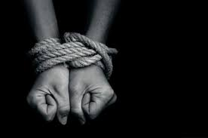 | international day for the abolition of slavery  According to the International Labour Organization, more than 40 million people worldwide are victims of modern day slavery. Modern Day Slavery is an umbrella term used to cover practices such as forced labour, debt bondage, forced marriage, and human trafficking. In addition, more than 150 million children are subject to child labour, accounting for almost one in ten children around the world.  The focus of this day is on the eradication of these contemporary forms of slavery.
Dec. 3 | international day of persons with disabilities  The annual observance of this day was proclaimed in 1992. It aims to promote the rights and well-being of persons with disabilities in all spheres of society and development, and to increase awareness of the situation of persons with disabilities in every aspect of political, social, economic and cultural life.  International Day of People with Disabilities (IDPWD) stands by its conviction that a person is not inherently ‘disabled’…disability is NOT a feature of a person. We say that people have health impairments: some of us need wheelchairs to mobilise; some of us need seeing-eye dogs; some of us need assistive technology – just like some of us need glasses to read; or medication to manage pain; or an inhaler to manage asthma.  All people have different health impairments at some time in their lives. The difference is that most of the time your health impairment doesn’t stop you from functioning, being included or participating in your community.  IDPWD exists to make sure that environmental and social BARRIERS are identified, and to help everyone to work together to overcome them. We will never eradicate health impairments…but by overcoming barriers, then we eradicate disablement.
Dec. 10 | Human Rights Day  Human Rights Day is observed every year on the 10th of December. The Declaration of Human Rights establishes the equal worth of every person. Though its promise has yet to be realized all over the world, it has stood the test of time. The principles set out in the Declaration of Human Rights are as relevant today as they were in 1948. We can take action in our own daily lives and help to improve the lives of others around the world.
This is an important message for days when schools are open and buses are cancelled and your child is therefore unable to attend school.

Parents/Guardians are required to report their child’s absent by calling the Safe Arrival line (1-844-350-2646) or entering your child’s absence using the SchoolMessenger website or app prior to the start of school. Please use the “Bus Cancellation” absence code. Your child’s absence will be entered as a grant day that will not count as an absence on their report card or count against perfect attendance.

This process is intended to ensure that bussed students who attend school on a bus cancelled day arrive at school safely. It is important to be aware that if the absence is not entered, the SchoolMessenger system will generate calls asking you to verify the absence. The ‘Bus Cancellation’ absence code should only be used on days when busses
are cancelled in your school zone.
If you have any questions please contact your child’s school.

Fundraising Program through everyday purchases and for the Holidays!
Simply buy Gift Cards or Shop Online at hundreds of merchants such as Walmart, Amazon, Home Depot, Indigo and Esso and the school earns cash back
No extra cost, No fees, No strings attached!

Let's work together to reach our fundraising goal by shopping through FlipGive, starting now for the Holiday Season!
We’re excited to earn funds through FlipGive to help us raise money for Michaelle Jean Public School. From November 14th through the end of the school year, we can earn up to 30% cash back when you shop merchants like Sky Zone, Starbucks, Nike, Sport Chek and more.
To support our fundraising campaign:

1. Visit https://www.flipgive.com/c/157858
2. Click Shop Now
3. To view list of all merchants, scroll down and click on View All Brands (orange button)
4. Select available option to Buy Gift Cards or Shop Online

NOTE: Cash back earnings will be allocated to the school ONLY by using the link above.
To maximize funds earned:
Tip #1: Share the link with family, friends and colleagues. Perfect time for Holiday shopping!
Tip #2: Use Gift Cards to make your direct purchases in lieu of debit or credit cards
Tip #3: Shop these merchants with some of the highest give: Esso Price Privileges – 30%, Sky Zone – 16%, Indigo – 15%, Amazon – up to 10%

